Monday, December 10, 2018

CHAPTER 8

P.P.8.1

- At t = 0–, we have the equivalent circuit shown in Figure (a).

50mF

10 Ω

2 Ω

(a)

+

v

−

24V

+
−

2 Ω

(b)

+

v_{C}

−

24V

+
−

v_{L}
+

a

i

i

i(0–) = 24/(2 + 10) = 2 A, v(0–) = 2i(0–) = 4 V

hence, v(0⁺) = v(0–) = 4 V.

- At t = 0⁺, the switch is closed.

L(di/dt) = v_{L}, leads to (di/dt) = v_{L}/L

But, v_{C}(0⁺) + v_{L}(0⁺) = 24 = 4 + v_{L}(0+), or v_{L}(0+) = 20 V

(di(0⁺)/dt) = 20/0.4 = 50 A/s

C(dv/dt) = i_{C} leading to (dv/dt) = i_{C}/C

But at node a, KCL gives i(0⁺) = i_{C}(0⁺) + v(0⁺)/2 = 2 = i_{C}(0⁺) + 4/2

or i_{C}(0⁺) = 0, hence (dv(0⁺)/dt) = 0 V/s

(c) As t approaches infinity, the capacitor is replaced by an open circuit and the inductor is replaced by a short circuit.

v(∞) = 24 V, and i(∞) = 12 A.

P.P.8.2

(a) At t = 0-, we have the equivalent circuit shown in (a).

5 Ω

(a)

i_{L}

i_{R}

6A

4A

+

v_{L}

−

2H

10 μF

5 Ω

(b)

6A

+

v_{C}

−
+ −

v_{R}

b

a

i_{L}(0-) = –6A, v_{L}(0–) = 0, v_{R}(0–) = 0

At t = 0⁺, we have the equivalent circuit in Figure (b). At node b,

i_{R}(0⁺) = i_{L}(0⁺) + 6, since i_{L}(0⁺) = i_{L}(0–) = –6A, i_{R}(0⁺) = 0,

and v_{R}(0+) = 5i_{R}(0+) = 0. Thus, i_{L}(0) = –6 A, v_{C}(0) = 0, and v_{R}(0⁺) = 0.

(b) dv_{C}(0⁺)/dt = i_{C}(0⁺)/C = 4/0.2 = 20 V/s.

To get (dv_{R}/dt), we apply KCL to node b, i_{R} = i_{L} + 6, thus di_{R}/dt = di_{L}/dt.

Since v_{R} = 5i_{R}, dv_{R}/dt = 5di_{R}/dt = 5di_{L}/dt. But Ldi_{L}/dt = v_{L}, di_{L}/dt = v_{L}/L.

Hence, dv_{R}(0⁺)/dt = 5v_{L}(0⁺)/L.

Applying KVL to the middle mesh in Figure (b),

–v_{C}(0⁺) + v_{R}(0⁺) + v_{L}(0⁺) = 0 = 0 + 0 + v_{R}(0⁺), or v_{R}(0⁺) = 0

Hence, dv_{R}(0⁺)/dt = 0 = di_{L}(0⁺)/dt;

di_{L}(0⁺)/dt = 0, dv_{C}(0⁺)/dt = 20 V/s, dv_{R}(0⁺)/dt = 0.

(c) As t approaches infinity, we have the equivalent circuit shown below.

4A

5 Ω

i_{L}

6A

- = 6 + i_{L}(∞) leads to i_{L}(∞) = –2 A

v_{C}(∞) = v_{R}(∞) = 4x5 = 20 V

Thus, i_{L}(∞) = –2 A, v_{C}(∞) = v_{R}(∞) = 20 V

P.P.8.3

α = R/(2L) = 10/(2x5) = 1, ω_{o} = = 10

s_{1,2} = = –1 ± j9.95.

Since α < ω_{o}, we clearly have an underdamped response.

P.P.8.4 For t < 0, the inductor is connected to the voltage source and when the circuit reaches steady state, the inductor acts like a short circuit.

i(0-) = 50/10 = 5 = i(0+) = i(0)

The voltage across the capacitor is 0 = v(0-) = v(0+) = v(0).

For t > 0, we have a source-free RLC circuit.

3

α = R/(2L) = 5/(2x1) = 2.5

Since α < ω_{o}, we have an underdamped case.

s_{1,2} = = –2.5 ± j1.6583

i(t) = e^{-2.5t}[A₁cos1.6583t + A₂sin1.6583t]

We now determine A₁ and A₂.

i(0) = 10 = A₁

di/dt = –2.5{e^{–2.5t}[A₁cos(1.6583t) + A₂sin(1.6583t)]}
+ 1.6583e^{–2.5t}[–A₁sin(1.6583t) + A₂cos(1.6583t)]

di(0)/dt = –(1/L)[Ri(0) + v(0)] = –2.5A₁ + 1.6583A₂

= –1[5x10+0] = –1[50] = –2.5(10) + 1.6583A₂

A₂ = –15.076

Thus, i(t) = e^{–2.5t}(10 cos 1.6583t – 15.076 sin 1.6583t) A

P.P.8.5 α = 1/(2RC) = 1/(2x2x25x10⁻³) = 10

10

since α = ω_{o}, we have a critically damped response. Therefore,

v(t) = [(A₁ + A₂t)e^{–10t}]

v(0) = 0 = A₁ + A₂x0 = A₁, which leads to v(t) = [A₂te^{–10t}].

dv(0)/dt = –(v(0) + Ri(0))/(RC) = –2x0.05/(2x25x10⁻³) = –2

dv/dt = [(A₂ – 10A₂t)e^{–10t}]

At t = 0, –2 = A₂ therefore, v(t) = (–2t)e^{–10t} u(t) V

P.P.8.6 For t < 0, the switch is closed. The inductor acts like a short circuit while the capacitor acts like an open circuit. Hence,

i(0) = 3A and v(0) = 0.

- = 1/(2RC) = 1/(2x20x4x10⁻³) = 6.25

= 5

Since α > ω_{o}, this is an overdamped response.

s_{1,2} = = –2.5 and –10

Thus, v(t) = A₁e^{-2.5t} + A₂e^{-10t}

v(0) = 0 = A₁ + A₂, which leads to A₂ = –A₁

dv(0)/dt = –(v(0) + Ri(0))/(RC) = –(20x4.5)12.5 = –1125

But, dv/dt = –2.5A₁e^{-2.5t} –10A₂e^{-10t}

At t = 0, –1125 = –2.5A₁ – 10A₂ = 7.5A₁ since A₁ = –A₂

A₁ = –150, A₂ = 150

Thus, v(t) = 150(e^{–10t} – e^{–2.5t}) V

P.P.8.7 The initial capacitor voltage is obtained when the switch is in position a.

v(0) = [2/(2 + 1)]18 = 12 V

The initial inductor current is i(0) = 0.

When the switch is in position b, we have the RLC circuit with the voltage source.

- = R/(2L) = 10/(2x2.5) = 2

= 4

Since α < ω_{o}, we have an underdamped case.

s_{1,2} = = -2 ± j 3.464

Thus, v(t) = v_{f} + [(A₁cos3.464t + A₂sin3.464t)e^{-2t}]

where v_{f} = v(∞) = 15, the final capacitor voltage. We now impose the initial conditions to get A₁ and A₂.

v(0) = 12 = 15 + A₁ leads to A₁ = –3

The initial capacitor current is the same as the initial inductor current.

i(0) = C(dv(0)/dt) = 0 therefore, dv(0)/dt = 0

But, dv/dt = 3.464[{–A₁sin(3.464t) + A₂cos(3.464t)}e^{-2t}]
–2[{A₁cos(3.464t) + A₂sin(3.464t)}e^{–2t}]

dv(0)/dt = 0 – 2A₁ + 3.464A₂, which leads to A₂ = –6/3.464 = –1.7321

Thus, v(t) = 15– (1.7321 sin 3.464t + 3 cos 3.464t)e^{-2t} V

i = C(dv/dt), v_{R} = Ri = RC(dv/dt) = (1/4)dv/dt

= (1/4)[(6 – 6)cos(3.464t) + (2x1.7321 + 3x3.464)sin(3.464t)]e^{–2t}

v_{R}(t) = 3.464e^{–2t} sin3.464t V

P.P.8.8 When t < 0, v(0) = 0, i(0) = 0; for t > 0,
= 0.25

i(t) = i_{s} + A₁cost + A₂sint = 10 + A₁cos(0.25t) + A₂sin(0.25t)

i(0) = 0 = 10 + A₁, therefore A₁ = –10

Ldi(0)/dt = v(0) = 0

But di/dt = –A₁ 0.25sin(0.25t) + A₂ 0.25cos(0.25t)

At t = 0, di(0)/dt = 0 = 0 + 0.25A₂ leading to i(t) = 10(1 – cos(0.25t)) A

v(t) = Ldi/dt = 20x10x0.25sint = 50 sin(0.25t) V

P.P.8.9 At t = 0, the switch is open so that v(0) = 0, i(0–) = 0 (1)

For t > 0, the switch is closed. We have the equivalent circuit as in Figure (a).

10 Ω

(a)

3A

i

2 H

(1/20)FF

4 Ω

i_{C}

+

v

−

10 Ω

(b)

3A

i

4 Ω

i_{C}

v(0⁺) = 0, i(0⁺) = 0 (2)

–3 + i_{C} + i = 0 (3)

From (3), i(0⁺) = 0 means that i_{C}(0⁺) = 3, but i_{C}(0⁺) = Cdv(0⁺)/dt

which leads to dv(0⁺)/dt = i_{C}(0⁺)/C = 3/(1/20) = 60 V/s

As t approaches infinity, we have the equivalent circuit in (b).

i(∞) = 3 A, v(∞) = 4i(∞) = 12V (5)

Next we find the network response by turning off the current source as shown in
Figure (c).

10 Ω

(c)

i

2 H

(1/20)FF

4 Ω

i_{C}

+

v

−

i

Applying KVL gives –v – 10i_{C} + 4i + 2di/dt = 0 (6)

Applying KCL to the top node, i – i_{C} = 0

Namely, i = i_{C} = –Cdv/dt = –(1/20)dv/dt (7)

Combining (6) and (7), –v – (10/20)dv/dt – (4/20)dv/dt – (2/20)d²v/dt² = 0.

or (d²v/dt²) + 7(dv/dt) + 10 = 0

The characteristic equation is s² + 7s + 10 = 0 = (s + 2)(s + 5)

This means that v_{n} = (Ae^{-2t} + Be^{-5t}) and v_{f} = v(∞) = 12 V.

Thus, v = v_{f} + v_{n} v = 12 + (Ae^{-2t} + Be^{-5t}) (8)

v(0) = 0 = 12 + A +B, or A + B = –12 (9)

dv/dt = (–2Ae^{-2t} – 5Be^{-5t})

dv(0)/dt = 60 = –2A – 5B

2A + 5B = –60 (10)

From (9) and (10), A = 0 and B = –12.

Thus, v(t) = 12(1 – e^{-5t}) V for all t > 0.

But, from (3), i = 3 – i_{C} = 3 –(1/20)dv/dt = 3 –(1/20)(60)e^{-5t}

i(t) = 3(1 – e^{-5t}) A for all t > 0.

P.P.8.10 For t <0, 5u(t) = 0 so that v₁(0-) = v₂(0-) = 0 (1)

For t > 0, the circuit is as shown in Figure (a).

1 Ω

(a)

v₁

(1/3)F

20V

+
−

1 Ω

0.5F

v₂

+

v₂

−

1 Ω

(b)

20V

+
−

1 Ω

+

v₁

−

i₁ = C₁dv₁/dt, or dv₁/dt = i₁/C₁; likewise dv₂/dt = i₂/C₂

i₂(0⁺) = (v₁(0⁺) – v₂(0⁺))/1 = (0 – 0)/1 = 0

(20 – v₁(0⁺))/1 = i₁(0⁺) + i₂(0⁺), or 20 = i₁(0⁺)

Hence, dv₁(0⁺)/dt = 20/(1/2) = 40 V/s (2a)

dv₂(0⁺)/dt = 0 (2b)

As t approaches infinity, the capacitors can be replaced by open circuits as shown in Figure (b). Thus,

v₁(∞) = v₂(∞) = 20V (3)

Next we obtain the network response by considering the circuit in Figure (c).

1 Ω

(c)

v₁

(1/3)F

1 Ω

0.5F

v₂

Applying KCL at node 1 gives (v₁/1) + (1/2)(dv₁/dt) + (v₁ – v₂)/1 = 0

or v₂ = 2v₁ + (1/2)dv₁/dt (4)

Applying KCL at node 2 gives (v₁ – v₂)/1 = (1/3)dv₂/dt

or v₁ = v₂ + (1/3)dv₂/dt (5)

Substituting (5) into (4) yields,

v₂ = 2v₂ +(2/3)(dv₂/dt) + (1/2)(dv₂/dt) + (1/6)d²v₂/dt²

or, (d²v₂/dt²) + (7dv₂/dt) + 6v₂ = 0

Now we have, s² + 7s + 6 = 0 = (s + 1)(s + 6)

Thus, v_{2n} = (Ae^{-t} + Be^{-6t}) and v_{2f} = v₂(∞) = 20V.

v₂ = v_{2n} + v_{2f} = 20 + (Ae^{-t} + Be^{-6t})

v₂(0) = 0 which implies that A + B = –20 (6)

dv₂/dt = (–Ae^{-t} – 6Be^{-6t})

dv₂(0) = 0 = –A – 6B (7)

From (6) and (7), A = –24 and B = 4.

Thus, v₂(t) = (20 – 24e^{-t} + 4e^{-6t}) V

From (5), v₁ = v₂ + (1/3)dv₂/dt

Thus, v₁(t) = (20 – 16e^{-t} – 4e^{-6t}) V

Now we can find, v_{o} = v₁ – v₂ = 8(e^{–t} – e^{–6t}) V, t > 0

P.P.8.11 Let v₁ equal the voltage at non-inverting terminal of the op amp. Then v_{o} is equal to the output of the op amp.

At the non-inverting terminal, (v_{s} – v_{o})/R₁ = C₁dv₁/dt (1)

At the output terminal of the op amp, (v₁ – v_{o})/R₂ = C₂dv_{o}/dt (2)

We now eliminate v₁ from (2), v₁ = v_{o} + R₂C₂dv_{o}/dt (3)

From (1) v_{s} = v₁ + R₁C₁dv₁/dt (4)

Substituting (3) into (4) gives

v_{s} = v_{o} + R₂C₂dv_{o}/dt + R₁C₁dv_{o}/dt + R₁C₁R₂C₂d²v_{o}/dt²

or d²v_{o}/dt² + [(1/(R₁C₁)) + (1/(R₂C₂))]dv_{o}/dt + v_{o}/(R₁R₂C₁C₂) = v_{s}/(R₁R₂C₁C₂)

With the given parameters,

(R₁R₂C₁C₂) = 10⁴x10⁴x20x10⁻⁶x100x10⁻⁶ = 2x10⁻²

1/(R₁R₂C₁C₂) = 5

[(1/(R₁C₁)) + (1/(R₂C₂))] = 10⁻⁴[(1/20x10⁻⁶) + (1/200x10⁻⁶)] = 6

Hence, we now have s² + 6s + 5 = 0 = (s +1)(s + 5)

Therefore v_{on} = Ae^{-t} + Be^{-5t}, and v_{of} = 10V

Thus, v_{o} = 10 + Ae^{-t} + Be^{-5t} (5)

For t < 0, v_{s} = 0, v₁(0–) = 0 = v_{o}(0–)

For t > 0, v_{s} = 10, but

v₁(0⁺) – v_{o}(0⁺) =0 (6)

From (2), dv_{o}(0⁺)/dt = [v₁(0⁺) – v_{o}(0⁺)]/R₂C₂ = 0 (7)

Imposing these conditions on v_{o}(t),

0 = 10 + A + B (8)

0 = –A – 5B or A = –5B (9)

From (8) and (9), A = –12.5 and B = 2.5

v_{o}(t) = (10 – 12.5e^{-t} + 2.5e^{-5t}) V, t > 0

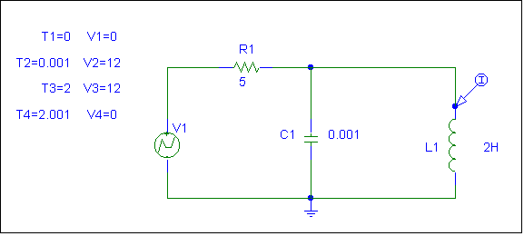
P.P.8.12 We follow the same procedure as in Example 8.12. The schematic is shown in Figure (a). The current marker is inserted to display the inductor current. After simulating the circuit, the required inductor current is plotted in Figure (b).

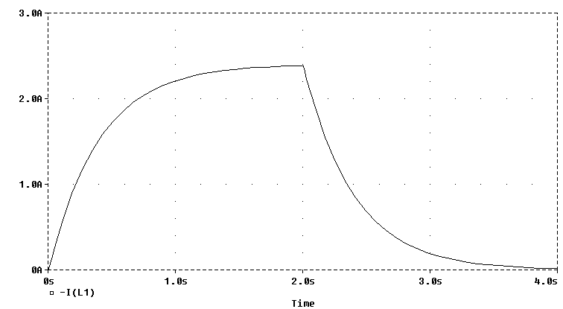

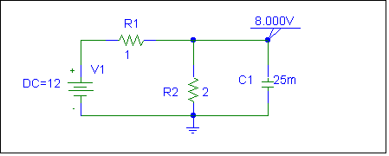
P.P.8.13 When the switch is at position a, the schematic is as shown in Figure (a). We carry out dc analysis on this to obtain initial conditions. It is evident that v_{C}(0) = 8 volts.

(a)

With the switch in position b, the schematic is as shown in Figure (b). A voltage marker is inserted to display the capacitor voltage. When the schematic is saved and run, the output is as shown in Figure (c).

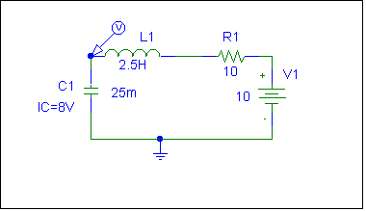

(b)

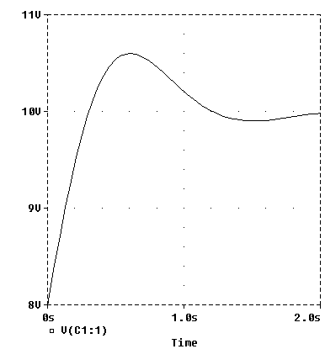

P.P.8.14 The dual circuit is obtained from the original circuit as shown in Figure (a). It is redrawn as shown in Figure (b).

0.1 Ω

10 Ω

(a)

3 H

4 H

3 F

4 μF

50mV

+
−

50mA

0.1 Ω

(b)

3 H

4 F

50mV

+
−

P.P.8.15 The dual circuit is obtained in Figure (a) and redrawn in Figure (b).

5 Ω

3 Ω

(a)

4 H

0.2 H

4 F

0.2F

20 V

+
−

2A

20A

2V

+
−

0.2 Ω

1/3 Ω

(b)

0.2 H

4F

20A

2V

+
−

1/5 Ω

1/3 Ω

P.P.8.16 Since 12 = 4i + v_{L} + v_{C} or v_{C} = 12 – 4i - v_{L}

–(v_{C} – 12) = 4i + v_{L} = e^{-250t}(12cosω_{d}t + 0.2684sinω_{d}t – 268sinω_{d}t)

v_{C}(t) = 12 – 12e^{-250t} cos 11,180t + 267.7e^{-250t} sin 11,180t V

P.P.8.17 We follow the same procedure as in Example 8.17. The schematic is as shown in Figure (a) with two voltage markers to display both input and output voltages. When the schematic is saved and run, the result is as displayed in Figure (b).
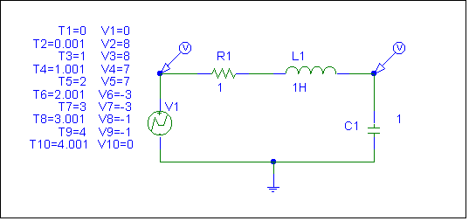

(a)

(a)

